Chinese OVG Partner Editorial DPS

AD SPECS
Size: | 296 mm (wide) x 210 mm (high)
Images: | 1 high resolution hero JPEG image & up to 4 high resolution supplementary JPEG images for consideration (minimum file size of 2MB)
Word Limit: | 500 words including headings, copy and call to action
Logo: | No
QR Code: | No

Note:
- Image montages or images with text over the top will not be accepted

ARTWORK EXAMPLE
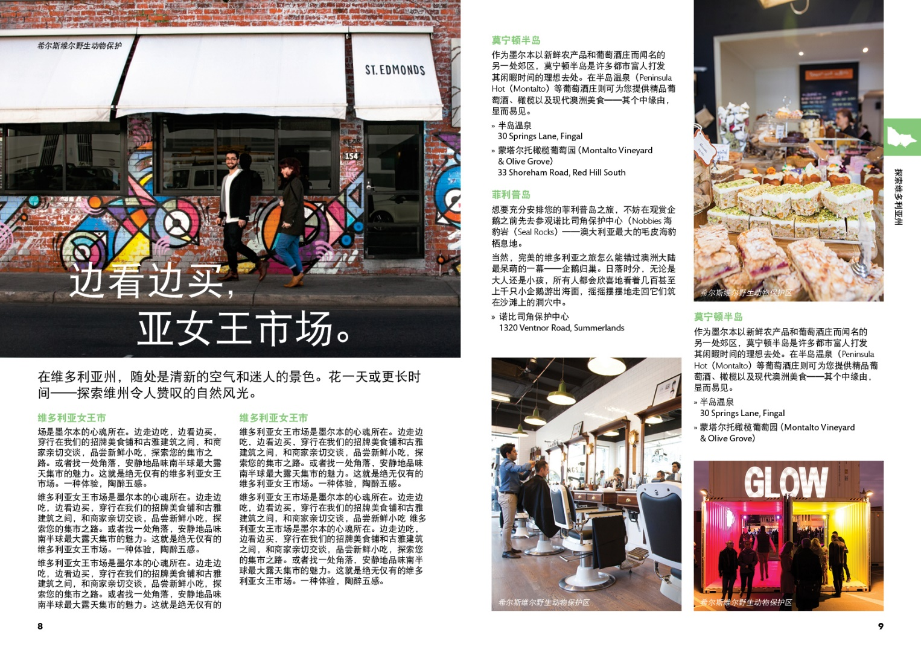

PROOFING
When a proof is ready for review on the OVhub, an email notification will be sent with a hyperlink to access the OVhub. Clients are granted the opportunity to review their OVG print proof two times.

Note:
- Changes made beyond the second proof at the clients request will incur an additional fee of $60 per proof.
- Screen representation for colour matching cannot be guaranteed and will depend solely upon the advertiser’s computer hardware.
- Destination Melbourne will take no responsibility for dissatisfaction due to colour difference between proof and final printed product.

